HONORS CHEMISTRY • UNIT 3
Chemical Bonding
Why atoms stick together, how they share or trade electrons, and how the shape and polarity of a molecule decide how a substance behaves.

TEACHER EDITION
Everything in a light-gray box or cell is an answer or model response. Teacher notes (misconceptions, demo ideas, discussion prompts, sources) appear in the heavy-bordered boxes labeled TEACHER NOTE. The pages follow the student packet, so they line up closely.

What we will learn
3.1 | Types of chemical bonds: ionic and covalent
3.2 | Properties of ionic and covalent compounds
3.3 | Lewis diagrams for ionic and covalent compounds
3.4 | Lewis structures & VSEPR theory (shapes and angles)
3.5 | Bond polarity & molecular polarity
★ | Extra practice & unit review

By the end of this unit I can…
• Explain what a full octet is and how atoms reach one by losing, gaining or sharing electrons.
• Predict whether a compound is ionic or covalent and describe the bond using metals/non-metals and electronegativity.
• Connect bonding type to properties: melting point, state at room temperature and electrical conductivity.
• Use Lewis dot diagrams to model ionic compounds and to draw Lewis structures for covalent molecules and polyatomic ions.
• Compare single, double and triple bonds in terms of bond length and strength.
• Use VSEPR theory to predict molecular shapes and bond angles.
• Use electronegativity, bond dipoles and shape to decide whether a molecule is polar or non-polar.
Unit at a glance (teacher)
Topic | Suggested pacing | Depth the homework expects
3.1 Types of bonds | 1 day | Octet; metal/non-metal and cation/anion table (Na, F, Al, B, N, S); ionic vs covalent classification (NO₂, MgBr₂, CaO, PI₃, SO₂, CaI₂); single/double/triple.
3.2 Properties | 1–2 days | Melting points of ionic vs covalent; explain with the bond; conductivity of solids, melts and solutions; predict H₂S.
3.3 Lewis diagrams | 2 days | Lewis dot models of K₂O, CaO and Li₃N; formulas from electron transfer; C–C, C=C, C≡C bond length and attraction.
3.4 VSEPR | 2–3 days | Explain VSEPR in own words; Lewis structure + shape + angle for NO₃⁻, OF₂, PF₅, CO₂, PH₃, SCl₆; shape around each atom of a large molecule.
3.5 Polarity | 2 days | Arrows toward the more electronegative atom, C–H not polar, EN order F > O > Cl > N; polar or non-polar and partial charges.

TEACHER OVERVIEW
Big picture. Bonding connects Unit 2 (electron configurations, electronegativity) to everything that follows: intermolecular forces, reactions, solutions. Students should be able to go from a formula → bond type → Lewis structure → shape → polarity → properties in one chain.
Misconceptions to watch for:
• “Ionic bonds are just attractions between two atoms.” (They are attractions among many ions in a lattice; there is no ionic molecule.)
• “Covalent bonds are weaker than ionic.” (Compare *intramolecular* covalent bonds with *intermolecular* forces: covalent compounds melt at low temperatures because of weak forces BETWEEN molecules, not because the covalent bond itself is weak.)
• Calling the formula of an ionic compound a “molecule” (use formula unit).
• “Polar bonds always make polar molecules.” (CO₂ and CCl₄ cancel.)
• Counting lone pairs as bonds when naming the shape (shape names only the atoms; the electron-pair geometry counts everything).
• Putting the ion charge on the wrong side of the bracket, or forgetting the brackets around a polyatomic ion.

IMAGES
All structures in this packet are drawn to print in black and white. Spots marked IMAGE GOES HERE are for the homework figures (the conductivity beakers in 3.2 and the large molecule in 3.4).

TOPIC  3.1 | Types of Chemical Bonds  Octet rule • ionic bonds • covalent bonds

BIG IDEA
Atoms bond to reach a full outer shell of 8 electrons (an octet; 2 for hydrogen and helium), the arrangement of the noble gases. They get there in one of two ways: transfer electrons (ionic bond) or share electrons (covalent bond).

Key vocabulary — write each definition in your own words
Term | Definition (your words) | Example / sketch
Octet | A full outer energy level of 8 valence electrons (s²p⁶). Atoms bond to obtain one. Hydrogen and helium are full with 2. | Neon: 2s² 2p⁶
Ionic bond | The electrostatic attraction between a positive cation and a negative anion, formed when a metal transfers electrons to a non-metal. | Na⁺ and Cl⁻ in NaCl
Covalent bond | A bond formed when two non-metal atoms share one or more pairs of electrons. | H–H in H₂
Cation / anion | A cation is a positive ion (an atom that lost electrons); an anion is a negative ion (an atom that gained electrons). | Mg²⁺, Cl⁻
Molecule | A neutral group of two or more non-metal atoms held together by covalent bonds. Ionic compounds are NOT molecules; they are lattices described by a formula unit. | H₂O, CO₂
Bond order (single / double / triple) | The number of shared pairs between two atoms: single = 1 pair (2 e⁻), double = 2 pairs (4 e⁻), triple = 3 pairs (6 e⁻). | O=O is a double bond

THINK OF IT LIKE… TRADING CARDS VS. SHARING A TOY
An ionic bond is like a trade where one kid hands over a card for good and the two are now stuck together by the deal (opposite charges). A covalent bond is two kids sharing one toy: neither owns it outright, and the toy keeps them together.

What does it mean to have a full octet?
1. In your own words, what is a full octet and why do atoms “want” one?
An atom has a full octet when its outer energy level holds 8 valence electrons, the same stable arrangement as a noble gas (s²p⁶). A full outer shell is a lower-energy, more stable arrangement, so atoms lose, gain or share electrons to reach it.

Ionic bonds
2. Which type of element typically forms a cation, and does it give or take electrons? Which type forms an anion, and does it give or take electrons?
Metals form cations by giving away (losing) their few valence electrons. Non-metals form anions by taking (gaining) electrons to complete the octet.

CUES / KEY WORDS  Metal  Non-metal  Why does the ion form? | HOW A SODIUM ATOM AND A CHLORINE ATOM FORM AN IONIC BOND  Na ([Ne] 3s¹) has 1 valence electron; losing it leaves [Ne], a full octet, so Na → Na⁺. Cl ([Ne] 3s² 3p⁵) has 7 valence electrons; gaining 1 makes [Ar], so Cl → Cl⁻. The electron moves from Na to Cl and the two opposite ions attract each other: an ionic bond.

Predicting ion charges
Use the periodic table. For each element: count the valence electrons, decide whether the atom loses or takes electrons, and give the ion’s charge.
Element | # of valence e⁻ | Lose or take e⁻? | Cation or anion? | Ion charge
Sodium | 1 | lose 1 | cation | 1+
Fluorine | 7 | take 1 | anion | 1−
Aluminum | 3 | lose 3 | cation | 3+
Boron | 3 | lose 3 | cation | 3+
Nitrogen | 5 | take 3 | anion | 3−
Sulfur | 6 | take 2 | anion | 2−

TEACHER NOTE
Boron is a metalloid and forms covalent compounds almost exclusively; the homework asks for the “textbook” ion (B³⁺). Mention that B³⁺ is rare in real life. Rule of thumb for students: groups 1, 2, 13 → 1+, 2+, 3+; groups 15, 16, 17 → 3−, 2−, 1−.

QUICK RULE
• Group 1 → 1+, Group 2 → 2+, Group 13 → 3+.
• Group 15 → 3−, Group 16 → 2−, Group 17 → 1−.
• Transition metals often form more than one charge (Fe²⁺ or Fe³⁺); you will see these in Unit 4.

Covalent bonds
3. How is a covalent bond different from an ionic bond? Talk about the elements that form it and what happens to the electrons.
A covalent bond forms between two non-metal atoms that SHARE electrons so that each atom counts the shared pair toward its own octet. An ionic bond forms between a metal and a non-metal; electrons are TRANSFERRED completely, creating ions that attract.

4. Some compounds contain single, double and triple bonds. What is the difference between them?
They differ in the number of shared electron pairs: a single bond shares 1 pair (2 e⁻), a double bond shares 2 pairs (4 e⁻), a triple bond shares 3 pairs (6 e⁻). More shared pairs means a shorter, stronger bond.

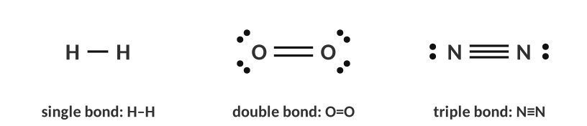
Single, double and triple bonds.
Ionic or covalent?
SHORTCUT
metal + non-metal → ionic
non-metal + non-metal → covalent
(If you are unsure, compare electronegativity: a difference larger than about 1.7 means ionic. See 3.5.)

Compound | 1st element: metal or non-metal? | 2nd element: metal or non-metal? | Ionic or covalent?
NO₂ | non-metal | non-metal | covalent
MgBr₂ | metal | non-metal | ionic
CaO | metal | non-metal | ionic
PI₃ | non-metal | non-metal | covalent
SO₂ | non-metal | non-metal | covalent
CaI₂ | metal | non-metal | ionic

More practice | Ionic or covalent?
KCl | ionic
CCl₄ | covalent
Li₃N | ionic
H₂O | covalent
Al₂O₃ | ionic
CH₄ | covalent
NH₄Cl | ionic (contains the polyatomic ion NH₄⁺; covalent bonds inside the ion, ionic bond between the ions)

5. An ionic bond forms when…
A) two non-metals share electrons
B) a metal transfers electrons to a non-metal
C) two metals share electrons
D) two noble gases attract

6. How many electrons are shared in a double bond?
A) 2
B) 4
C) 6
D) 8

7. Which element is most likely to form a 2− ion?
A) Na
B) Cl
C) O
D) Mg

8. Which compound is covalent?
A) MgO
B) SO₂
C) KBr
D) CaCl₂

TOPIC  3.2 | Properties of Ionic and Covalent Compounds  Melting point • state • conductivity • brittleness

BIG IDEA
The kind of bond decides how a substance behaves: ionic compounds are hard, brittle, high-melting solids that conduct only when their ions can move; covalent (molecular) compounds usually melt at low temperatures and do not conduct.

Key vocabulary — write each definition in your own words
Term | Definition (your words) | Example / sketch
Crystal lattice | A repeating three-dimensional pattern of alternating cations and anions held together by strong attractions in every direction. | NaCl crystal
Formula unit | The simplest whole-number ratio of ions in an ionic compound; it is NOT a separate particle. | NaCl, MgBr₂
Melting point | The temperature at which a solid becomes a liquid; you must overcome the forces holding the particles in place. | Ice: 0 °C
Electrical conductor | A substance that carries electric current. It needs charged particles (ions or electrons) that are free to move. | Molten NaCl, copper wire
Electrolyte | A substance that forms ions when dissolved in water so the solution conducts electricity. | NaCl(aq) yes; C₆H₁₂O₆(aq) no

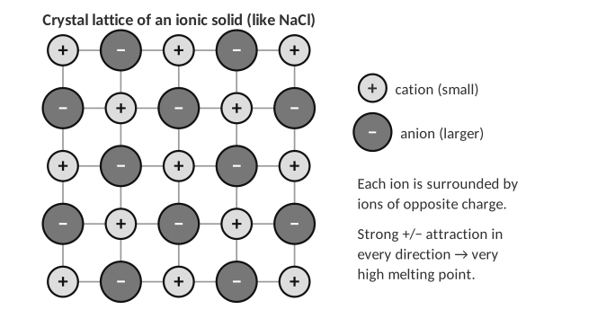
Melting points tell you about the bond
The table lists data for six substances. Classify each as ionic or covalent, then answer the questions that follow.
Substance | Ionic or covalent? | Melting point | State at room temp.
CaCl₂ | ionic | 772 °C | solid
H₂O | covalent | 0 °C | liquid
MgO | ionic | 2852 °C | solid
NH₃ | covalent | −77 °C | gas
SrO | ionic | 2531 °C | solid
H₂S | covalent | low (about −86 °C) | gas
C₆H₁₂O₆ | covalent | 146 °C | solid

1. Some compounds have a large difference in melting point. Use the type of bond to explain why the ionic compounds melt at much higher temperatures.
Ionic compounds are made of a lattice of cations and anions held by very strong electrostatic attractions in all directions; a lot of energy (heat) is needed to pull the ions apart. Covalent compounds are separate molecules: melting only requires overcoming the weak attractions BETWEEN molecules (intermolecular forces), not the covalent bonds inside them, so they melt at much lower temperatures.

2. Based on this trend, do you expect H₂S to have a high or low melting point? Explain using the bond found in H₂S.
Low (actual: −86 °C). H₂S is covalent (two non-metals); it exists as separate molecules held together by weak intermolecular forces, so little energy is needed to separate them.

TEACHER NOTE — MELTING POINTS
Be explicit about the word choice: students often write “covalent bonds are weak.” Correct it to “the forces between covalent molecules are weak.” Glucose (146 °C) is a good example of a covalent solid that melts higher than H₂O because it is a bigger molecule with more hydrogen bonding (preview of Unit 8/IMF). Diamond and quartz (network covalent) are the exceptions; mention them but don’t test them.

Why ionic crystals are brittle
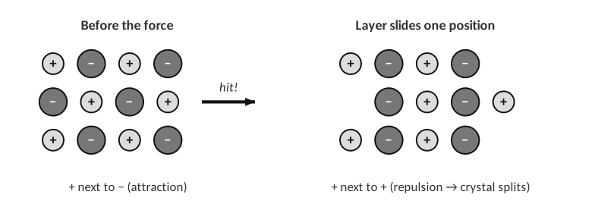
A hammer blow slides one layer of ions.
3. Explain why a salt crystal shatters when you hit it, while a metal bends.
Hitting the crystal shifts one layer of ions by one position, so ions of the same charge line up and repel; the crystal splits. In a metal the electrons are shared among all atoms so layers can slide without repulsion.

LAB CORNER • Conductivity testing

A student uses a conductivity tester (two electrodes, a battery and a light bulb) to test substances. If current can flow through the sample, the bulb lights.
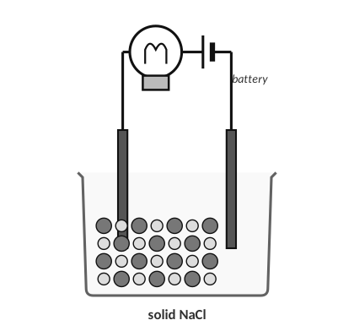 | 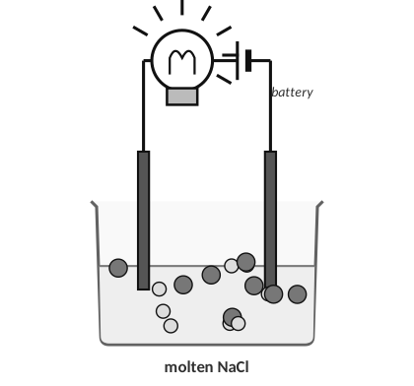
A: solid NaCl | B: molten NaCl

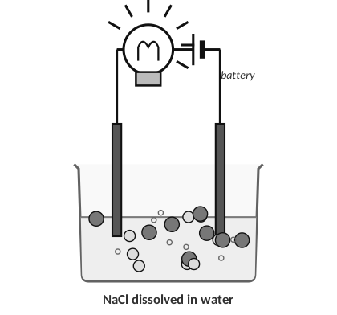 | 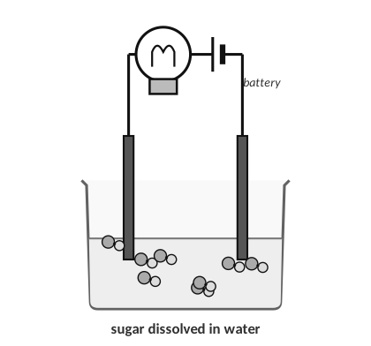
C: NaCl dissolved in water | D: sucrose dissolved in water

[ IMAGE GOES HERE ]
Optional: conductivity beakers from the homework

4. For a substance to conduct electricity, what must be present?
Charged particles (ions or free electrons) that are free to move.

5. Which beakers should the student expect to light the bulb? Explain.
B and C. In molten NaCl and in NaCl solution the Na⁺ and Cl⁻ ions are free to move and carry the current between the electrodes.

6. For the beakers you did not choose, explain why they do not conduct.
A: the ions are locked in fixed positions in the lattice, so they can’t move. D: sucrose is a covalent compound that dissolves as neutral molecules, so there are no ions in the solution to carry a charge.

7. Predict: would distilled water light the bulb? Would tap water? Explain.
Distilled water: almost no ions, so no (or a very dim bulb). Tap water has a few dissolved ions (Ca²⁺, Mg²⁺, Cl⁻, …) so it conducts weakly. This is why you should not use electrical devices in water.

TEACHER NOTE — LAB IDEAS
Lab version: use 9 V battery + LED/bulb conductivity tester; test solid NaCl, tap water, distilled water, NaCl(aq), sucrose(aq), dilute HC₂H₃O₂(aq), KNO₃(aq) and ethanol. Have students predict first. Molten NaCl is a demonstration only (801 °C) — use a video. Safety: goggles; rinse electrodes between tests with distilled water.

Property | Ionic compounds | Covalent (molecular) compounds
Particles | cations and anions in a lattice | neutral molecules
Melting / boiling point | high | low
State at room temp. | solid | solid, liquid or gas
Conducts as a solid? | no | no
Conducts when molten or dissolved? | yes (ions move) | no (no ions)
Hardness | hard but brittle | often soft

8. Which substance would conduct electricity when melted but not as a solid?
A) C₆H₁₂O₆
B) MgO
C) H₂O
D) NH₃

9. Why does CaCl₂ have a much higher melting point than H₂O?
A) covalent bonds are stronger
B) ionic attractions among many ions are strong
C) water has no bonds
D) CaCl₂ is a gas

10. Which of these solutions does NOT conduct electricity?
A) KBr(aq)
B) NaOH(aq)
C) C₁₂H₂₂O₁₁(aq)
D) HCl(aq)

TOPIC  3.3 | Lewis Diagrams for Ionic and Covalent Compounds  Electron transfer • shared pairs • bond length

BIG IDEA
A Lewis diagram is a bookkeeping tool for valence electrons. For ionic compounds it shows electrons moving from metal to non-metal; for covalent compounds it shows shared pairs (bonds) and lone pairs.

Key vocabulary — write each definition in your own words
Term | Definition (your words) | Example / sketch
Lewis dot diagram (atom) | The element symbol surrounded by one dot per valence electron. | O has 6 dots; Na has 1.
Bonding pair | A pair of electrons shared between two atoms; drawn as a line between the atoms. | H–H
Lone pair | A pair of valence electrons on one atom that is not shared in a bond; drawn as two dots. | Water’s oxygen has two lone pairs.
Formula unit (ionic) | The lowest whole-number ratio of cations to anions that makes the total charge zero. | K₂O: 2 K⁺ for 1 O²⁻
Bond length | The distance between the nuclei of two bonded atoms; more shared pairs pull the nuclei closer. | C≡C is shorter than C–C.

Ionic compounds: show the electron transfer
STEPS
1. Draw each atom with its valence electrons as dots.
2. Draw an arrow from each metal to the non-metal for every electron transferred.
3. Draw the ions in brackets: the cation shows NO dots (its outer shell is gone); the anion shows 8 dots.
4. Write the charge outside the bracket, and use as many metal atoms as it takes so that the electrons given = electrons taken.

WORKED EXAMPLE — POTASSIUM OXIDE
Use Lewis dot diagrams to show why potassium oxide is K₂O.

K has 1 valence electron; O needs 2 more to reach 8. One K can supply only 1 electron, so two K atoms give one electron each to one O atom.
Result: 2 K⁺ and 1 O²⁻ → charges 2(+1) + (−2) = 0 → K₂O.

Answer: K₂O
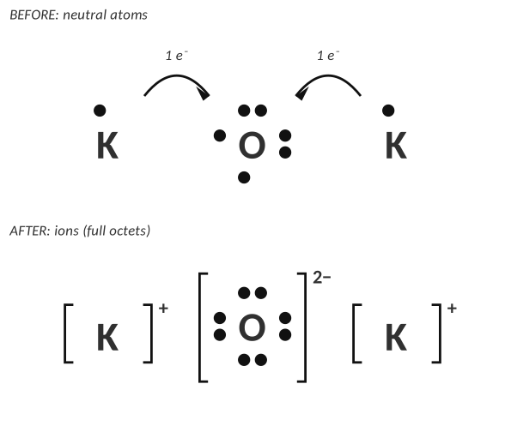
Potassium oxide: two K⁺ for each O²⁻.
Your turn
Draw Lewis dot diagrams (with arrows and brackets) for each compound and write its formula.
1. Calcium oxide: calcium + oxygen
Ca has 2 valence electrons; O needs 2. One Ca gives 2 e⁻ to one O → Ca²⁺ and O²⁻ → CaO (1:1 ratio).

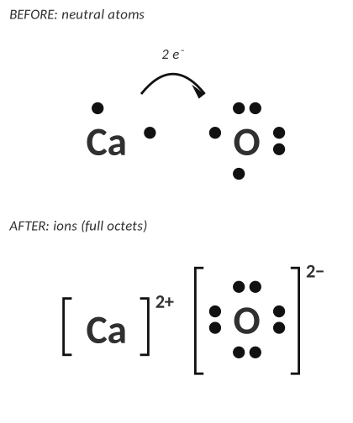
Answer: CaO.
2. Lithium nitride: lithium + nitrogen. (The label on a bottle has worn off, but the student knows it contains lithium and nitrogen.)
Li has 1 valence electron; N needs 3. Three Li atoms each give 1 e⁻ to one N atom → 3 Li⁺ and N³⁻ → Li₃N.

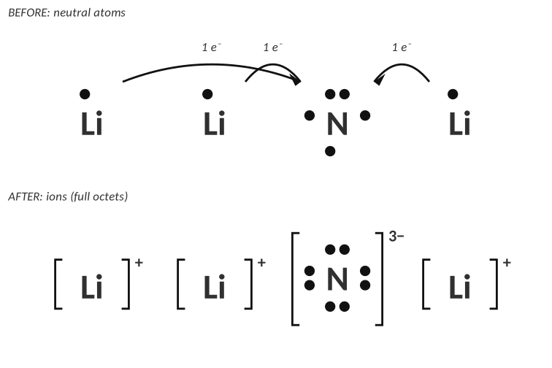
Answer: Li₃N.
3. Magnesium chloride: magnesium + chlorine.
Mg has 2 valence electrons; each Cl needs only 1. One Mg gives one e⁻ to each of two Cl atoms → Mg²⁺ + 2 Cl⁻ → MgCl₂.

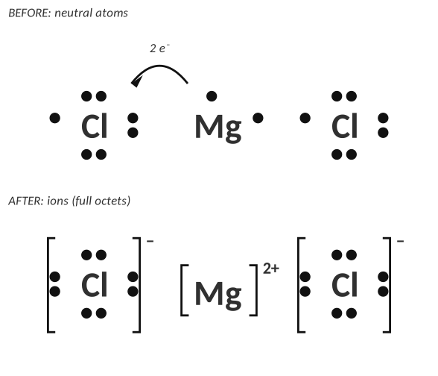
Answer: MgCl₂.
4. Both K₂O and CaO contain oxygen. Explain why one formula has a subscript 2 and the other doesn’t.
Potassium loses 1 electron (K⁺) and oxygen needs 2, so two potassium atoms are needed for each O. Calcium loses 2 electrons (Ca²⁺), exactly what one oxygen needs, so the ratio is 1:1.

TEACHER NOTE
Crisscross shortcut (preview of Unit 4 naming): K⁺ and O²⁻ → K₂O¹; Ca²⁺ and O²⁻ → Ca₂O₂ → reduce to CaO. Make sure students can justify the formula with electrons first.

Covalent compounds: Lewis structures step by step
STEPS
1. Count total valence electrons (add one electron for each negative charge; subtract one for each positive charge).
2. Skeleton: put the least electronegative atom in the middle (never H, never F). Connect the atoms with single bonds (2 e⁻ each).
3. Outer atoms first: add lone pairs to the outside atoms until each has 8 (H gets 2).
4. Leftover electrons go on the central atom.
5. If the central atom has fewer than 8, move a lone pair from an outer atom to make a double (or triple) bond.
6. Check: every atom has an octet (H has 2), and the electron count matches step 1.

WORKED EXAMPLE — WATER
Draw the Lewis structure of H₂O.

1. Valence e⁻: 2(1) + 6 = 8.
2. O in the middle; H–O–H uses 4 e⁻.
3. H already has 2. The remaining 4 e⁻ go on O as 2 lone pairs.
4. O has 4 + 4 = 8 ✓.

Answer: see structure
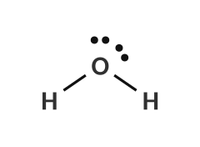
WORKED EXAMPLE — CARBON DIOXIDE
Draw the Lewis structure of CO₂.

1. Valence e⁻: 4 + 2(6) = 16.
2. O–C–O uses 4 e⁻; 12 left.
3. Put 6 e⁻ (3 pairs) on each O → carbon has only 4 e⁻.
4. Move one lone pair from each O into a bond: O=C=O. Each atom now has 8 ✓.

Answer: O=C=O
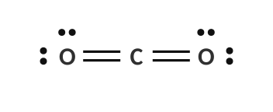
WORKED EXAMPLE — NITRATE ION
Draw the Lewis structure of NO₃⁻.

1. Valence e⁻: 5 + 3(6) + 1 (for the 1− charge) = 24.
2. N in the middle; three N–O bonds use 6 e⁻; 18 left.
3. Complete the octets on the 3 O atoms (6 e⁻ each = 18). N has only 6 e⁻.
4. Move a lone pair from one O to make an N=O double bond. N has 8 ✓.
5. Put the whole structure in brackets with the 1− charge. (The double bond could be on any of the three O atoms: these are resonance structures.)

Answer: see structure
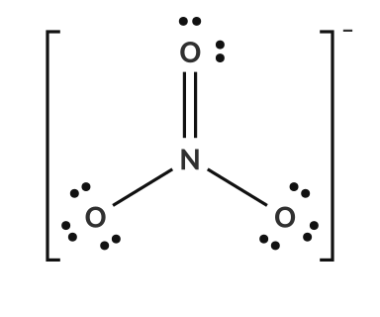
Count the electrons
Species | Valence-electron count | Total
NH₃ | 5 + 1 + 1 + 1 | 8
CH₄ | 4 + 1 + 1 + 1 + 1 | 8
HCN | 1 + 4 + 5 | 10
SO₂ | 6 + 6 + 6 | 18
PCl₃ | 5 + 7 + 7 + 7 | 26
NH₄⁺ | 5 + 1 + 1 + 1 + 1 −(1) | 8
CO₃²⁻ | 4 + 6 + 6 + 6 +2 | 24

Practice: draw the Lewis structures
Molecule | Lewis structure (draw it here)
NH₃
CH₄
HCN
SO₂
CH₂O
C₂H₄

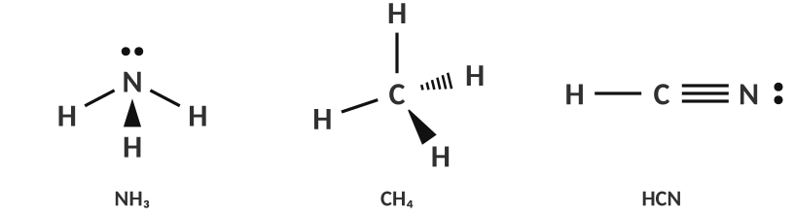
Answers: NH₃, CH₄, HCN
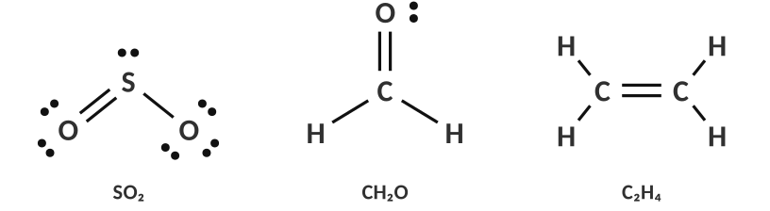
Answers: SO₂ (one resonance form), CH₂O, C₂H₄
Bond length and bond strength
A student is interested in the bond lengths of ethane (C₂H₆), ethene (C₂H₄) and ethyne (C₂H₂). Each carbon must have 8 electrons (4 bonds in total) and each hydrogen 2.
Compound | C–C bond type | Lewis structure | Bond length (pm) | Bond energy (kJ/mol)
C₂H₆ | single |  | 154 | 348
C₂H₄ | double |  | 134 | 614
C₂H₂ | triple |  | 120 | 839

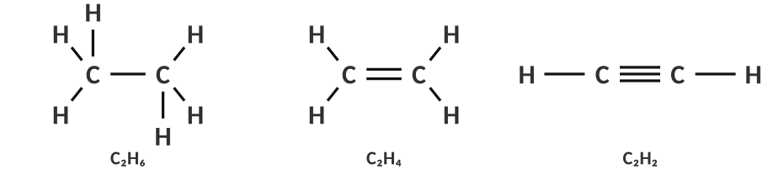
Answers: ethane, ethene, ethyne
5. Which of the carbon–carbon bonds is the shortest? Explain using the attraction between protons and electrons.
The triple bond (C≡C, 120 pm). Three shared pairs of electrons sit between the two nuclei; the greater negative charge between the positive nuclei attracts both nuclei more strongly (Coulomb’s law) and pulls them closer together, making the bond shorter and stronger than a double or single bond.

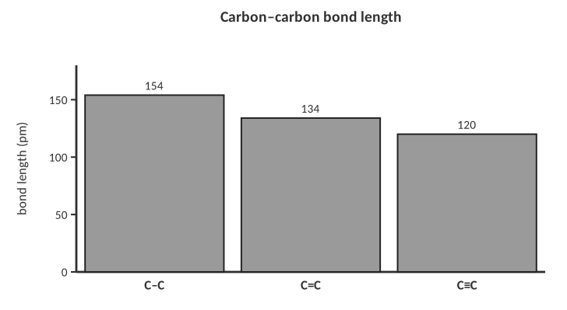
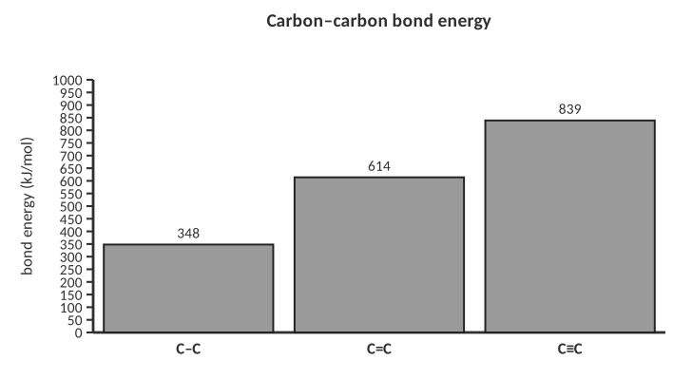
6. Describe the relationship between the number of shared pairs, bond length and bond energy.
More shared pairs → shorter bond length and higher bond energy (stronger bond that is harder to break).

7. Which is the correct total number of valence electrons for the Lewis structure of PO₄³⁻?
A) 29
B) 32
C) 30
D) 26

8. How many lone pairs are on the central atom of H₂O?
A) 0
B) 1
C) 2
D) 3

9. A compound is made of Mg²⁺ and N³⁻. What is the formula?
A) MgN
B) Mg₂N₃
C) Mg₃N₂
D) Mg₃N

TOPIC  3.4 | Lewis Structures & VSEPR Theory  Electron domains • shapes • bond angles

BIG IDEA
VSEPR (Valence Shell Electron Pair Repulsion) says that electron pairs around a central atom repel each other, so they spread out as far apart as possible. The resulting arrangement of the atoms is the shape of the molecule.

Key vocabulary — write each definition in your own words
Term | Definition (your words) | Example / sketch
Electron domain | A region around the central atom that contains electrons: a lone pair, a single bond, a double bond or a triple bond each count as ONE domain. | CO₂ has 2 domains on C.
Electron geometry | The arrangement of ALL the electron domains (bonds and lone pairs) around the central atom. | H₂O: tetrahedral (4 domains)
Molecular shape | The arrangement of only the ATOMS around the central atom; lone pairs affect the shape but are not named. | H₂O: bent
Bond angle | The angle between two bonds that meet at the same central atom. | H–O–H ≈ 104.5°
VSEPR theory | The idea that electron domains repel and so arrange themselves as far apart as possible to minimize repulsion. | Balloons tied together

THINK OF IT LIKE… TIED-TOGETHER BALLOONS
Tie 2 balloons together and they point in opposite directions (180°). Tie 3 and they make a flat triangle (120°). Four balloons form a tetrahedron (109.5°). Balloons are electron domains: they push each other apart as far as the knot allows. A fatter balloon (a lone pair, which takes more room than a bond) squeezes the others slightly closer.

In your own words: what is the big idea of VSEPR?
Electrons are negative, so regions of electrons (bonds and lone pairs) around a central atom repel one another. The molecule adopts the arrangement that places those regions as far apart as possible, which determines the molecule’s shape and bond angles.

HOW TO NAME A SHAPE
1. Draw the Lewis structure.
2. Count the electron domains on the central atom (each bond, whether single, double or triple, counts once; each lone pair counts once).
3. Count how many of the domains are lone pairs (E).
4. Use the chart below: the number of domains gives the electron geometry; the lone pairs remove positions to give the molecular shape.

The VSEPR chart (fill in the name and angle of every shape)
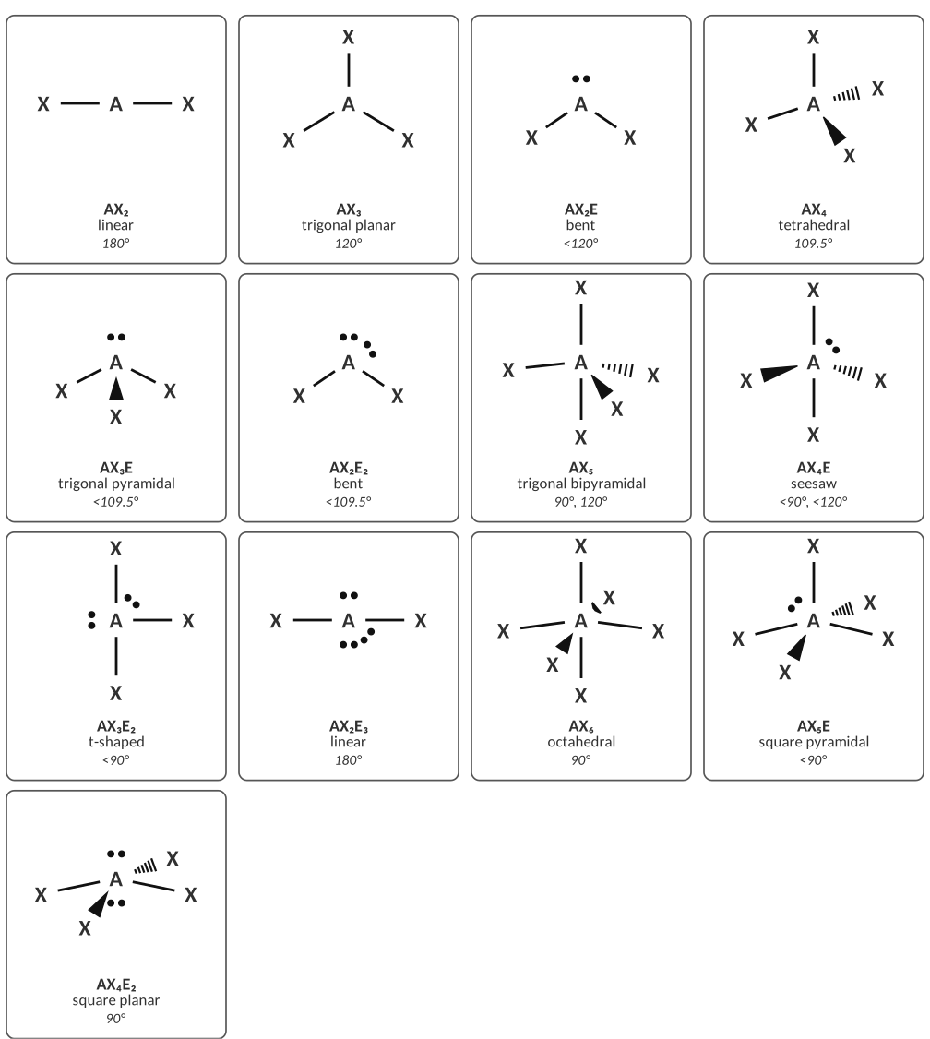
Answer key: A = central atom, X = bonded atoms, E = lone pairs.
Total domains | Electron geometry | Lone pairs (E) | Molecular shape
2 | linear | 0 | linear
3 | trigonal planar | 0 / 1 | trigonal planar / bent
4 | tetrahedral | 0 / 1 / 2 | tetrahedral / trigonal pyramidal / bent
5 | trigonal bipyramidal | 0 / 1 / 2 / 3 | trigonal bipyramidal / seesaw / T-shaped / linear
6 | octahedral | 0 / 1 / 2 | octahedral / square pyramidal / square planar

TEACHER NOTE — WHAT TO REQUIRE
Require the first 6 shapes (linear, trigonal planar, bent, tetrahedral, trigonal pyramidal, trigonal bipyramidal, octahedral) for all students. Seesaw, T-shaped, square pyramidal and square planar are on the AP course and are provided for enrichment. Lone pair repulsion is greater than bond-pair repulsion, so angles shrink: CH₄ 109.5°, NH₃ 107°, H₂O 104.5°. Equatorial positions are used first for lone pairs in trigonal bipyramidal geometry.

Worked examples
WORKED EXAMPLE — SHAPE OF NH₃
Give the Lewis structure, domains, shape and angle for NH₃.

Valence e⁻: 5 + 3 = 8. Three N–H bonds + 1 lone pair on N → 4 domains (tetrahedral electron geometry). One lone pair → trigonal pyramidal, angle ≈ 107° (less than 109.5° because the lone pair pushes harder).

Answer: trigonal pyramidal, ~107°
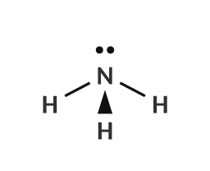
WORKED EXAMPLE — SHAPE OF CO₂
Give the shape and angle of CO₂.

Two double bonds on C and no lone pairs → 2 domains → linear, 180°. (A double bond is ONE domain.)

Answer: linear, 180°
Practice: Lewis structure, shape and angle
Draw each Lewis structure, then name the shape and the bond angle(s).
Compound | Lewis structure | Shape | Angle(s)
NO₃⁻ |  | trigonal planar | 120°
OF₂ |  | bent | ≈ 103° (< 109.5°)
PF₅ |  | trigonal bipyramidal | 90° and 120°
CO₂ |  | linear | 180°
PH₃ |  | trigonal pyramidal | ≈ 93.5° (< 109.5°)
SCl₆ |  | octahedral | 90°

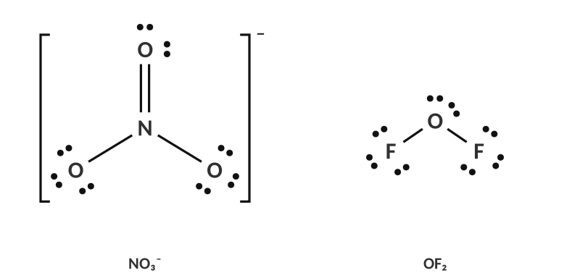
Answers: NO₃⁻ (one resonance form) and OF₂
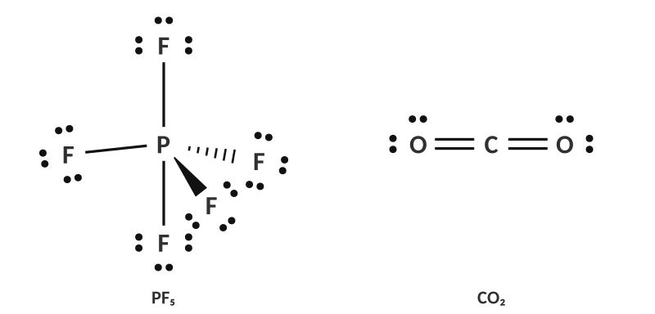
PF₅ and CO₂
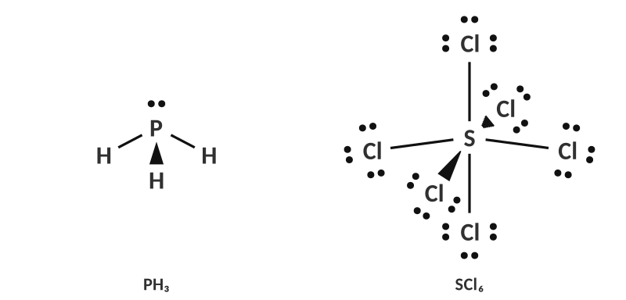
PH₃ and SCl₆
Identify the shape and angle of each structure shown
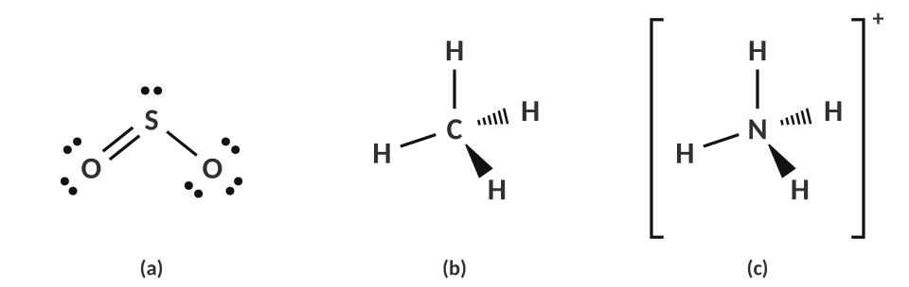
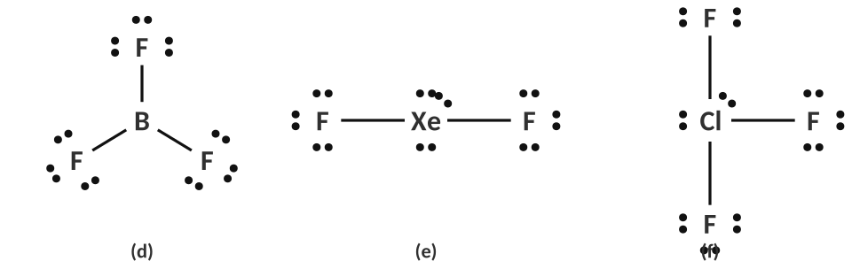
 | Domains on central atom | Electron geometry | Molecular shape | Angle
(a) SO₂ | 3 | trigonal planar | bent | < 120° (≈ 119°)
(b) CH₄ | 4 | tetrahedral | tetrahedral | 109.5°
(c) NH₄⁺ | 4 | tetrahedral | tetrahedral | 109.5°
(d) BF₃ | 3 | trigonal planar | trigonal planar | 120°
(e) XeF₂ | 5 | trigonal bipyramidal | linear | 180°
(f) ClF₃ | 5 | trigonal bipyramidal | T-shaped | < 90° (≈ 87.5°)

Shape around each atom of a larger molecule
Acetic acid (vinegar) has several “central” atoms. Name the shape and bond angle around each atom marked (a), (b) and (c).
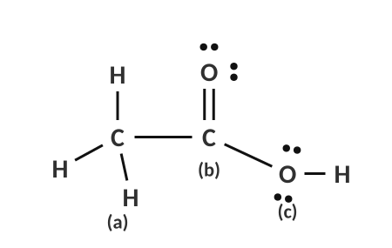
[ IMAGE GOES HERE ]
Optional: the large molecule from the homework

Atom | Domains | Shape | Angle
(a) the CH₃ carbon | 4 | tetrahedral | 109.5°
(b) the C=O carbon | 3 | trigonal planar | 120°
(c) the O–H oxygen | 4 (2 bonds, 2 lone pairs) | bent | ≈ 104.5°

1. Why is the angle in H₂O (104.5°) smaller than the ideal tetrahedral angle of 109.5°?
The two lone pairs on oxygen occupy more space than bonding pairs and push the two O–H bonds closer together, reducing the angle below 109.5°.

2. Both CO₂ and SO₂ have three atoms, but one is linear and the other is bent. Explain the difference.
Carbon in CO₂ has no lone pairs (2 domains → linear). Sulfur in SO₂ has 3 domains: 2 bonds and 1 lone pair, so the molecule is bent.

3. What is the shape of a molecule with 4 electron domains, 2 of which are lone pairs?
A) linear
B) bent
C) trigonal pyramidal
D) tetrahedral

4. PF₅ has what molecular shape?
A) octahedral
B) trigonal planar
C) trigonal bipyramidal
D) square planar

5. What is the approximate bond angle in CH₄?
A) 90°
B) 104.5°
C) 109.5°
D) 120°

6. Which species is trigonal planar?
A) NH₃
B) BF₃
C) PCl₃
D) H₂O

TOPIC  3.5 | Bond Polarity & Molecular Polarity  Electronegativity • dipoles • shape decides polarity

BIG IDEA
Electrons in a covalent bond are not always shared equally. The atom with the larger electronegativity pulls harder and becomes slightly negative. Whether the whole molecule is polar then depends on its shape: do the pulls add up or cancel?

Key vocabulary — write each definition in your own words
Term | Definition (your words) | Example / sketch
Electronegativity | A measure of how strongly an atom attracts the shared electrons in a bond. | F = 3.98 (highest), Cs = 0.79
Polar covalent bond | A covalent bond in which the electrons are shared unequally because the two atoms have different electronegativities. | H–O in water
Non-polar covalent bond | A covalent bond with equal (or nearly equal) sharing of electrons: same atoms or very close electronegativity. | Cl–Cl, C–H
Dipole / partial charge (δ+, δ−) | A separation of charge in a bond: the more electronegative atom is partially negative (δ−), the other partially positive (δ+). The dipole arrow points toward the δ− atom. | δ+ H–Cl δ−
Polar molecule | A molecule whose bond dipoles do not cancel, giving one end partial positive and the other partial negative. It needs polar bonds AND an asymmetric shape. | H₂O, NH₃

THINK OF IT LIKE… TUG-OF-WAR
Two teams pull on a rope (the shared electrons). If the teams are equally strong the flag stays in the middle (non-polar). If one team is stronger, the flag shifts toward them (polar). In a molecule with several teams pulling in different directions, it can still end in a draw: if three equal teams pull at 120° from each other, the flag doesn’t move (BF₃).

Step 1: the bond
RULE OF THUMB (ΔEN = DIFFERENCE IN ELECTRONEGATIVITY)
ΔEN < 0.4 → non-polar covalent
0.4 ≤ ΔEN ≤ 1.7 → polar covalent
ΔEN > 1.7 → ionic (electron is effectively transferred)
Carbon–hydrogen bonds (ΔEN = 0.35) are treated as non-polar: do not draw an arrow for C–H.
Order of the top four: F > O > Cl > N (then Br, I, S, C, H).

Bond | EN values | ΔEN | Bond type | More electronegative atom
H–H | 2.20, 2.20 | 0.00 | non-polar covalent | —
C–H | 2.55, 2.20 | 0.35 | non-polar covalent | —
C–Cl | 2.55, 3.16 | 0.61 | polar covalent | Cl
N–H | 3.04, 2.20 | 0.84 | polar covalent | N
O–H | 3.44, 2.20 | 1.24 | polar covalent | O
C–O | 2.55, 3.44 | 0.89 | polar covalent | O
Cl–F | 3.16, 3.98 | 0.82 | polar covalent | F
Mg–O | 1.31, 3.44 | 2.13 | ionic | O
Na–Cl | 0.93, 3.16 | 2.23 | ionic | Cl

TEACHER NOTE — THRESHOLDS
Cut-offs vary by textbook (0.4/1.7 here; some use 0.5/2.0 or 0.4/2.0). Tell students which one your assessments use. H–F has ΔEN = 1.78 and is a polar covalent bond despite the cut-off; say that the numbers are guidelines and that real bonds fall on a continuum. Pauling values used: H 2.20, C 2.55, N 3.04, O 3.44, F 3.98, Cl 3.16, Mg 1.31, Na 0.93.

1. Draw a dipole arrow and label δ+ and δ− on each of these bonds: H–Cl, H–O, H–N, C–F, and explain why the C–H bond gets no arrow.
The arrow (with a + at the tail) points toward the more electronegative atom, which is δ−: H→Cl, H→O, H→N, C→F. C–H: ΔEN = 0.35, so electrons are shared almost equally: non-polar.

Step 2: the molecule
IS THE MOLECULE POLAR?
1. Draw the Lewis structure and decide on the shape (3.4).
2. Draw a dipole arrow on every polar bond.
3. Ask: do the arrows cancel? Are the polar bonds arranged symmetrically (equal arrows pointing in opposite directions)?
4. If they cancel → non-polar. If there is a net pull to one side (or any lone pair on the central atom or different atoms attached) → polar: label partial charges on every atom.

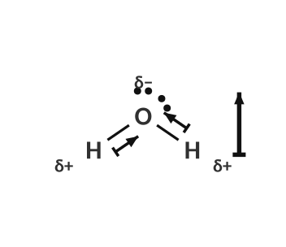
Water: bent, so the O–H arrows add up: polar.
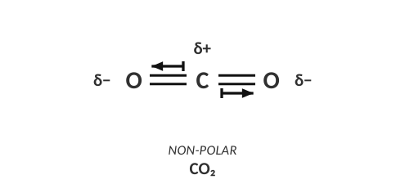
CO₂: two equal arrows in opposite directions cancel: non-polar.
2. CO₂ has polar bonds but is a non-polar molecule, while H₂O has polar bonds and is polar. Explain the difference using shape.
CO₂ is linear: the two equal C=O dipoles point in opposite directions and cancel. H₂O is bent (and has lone pairs on O), so its two O–H dipoles do not cancel and there is a net dipole toward oxygen.

Practice: draw the arrows, decide polar or non-polar
For each molecule, draw an arrow on every polar bond (toward the more electronegative atom), then write POLAR or NON-POLAR and label any partial charges. Use the Lewis structures given.
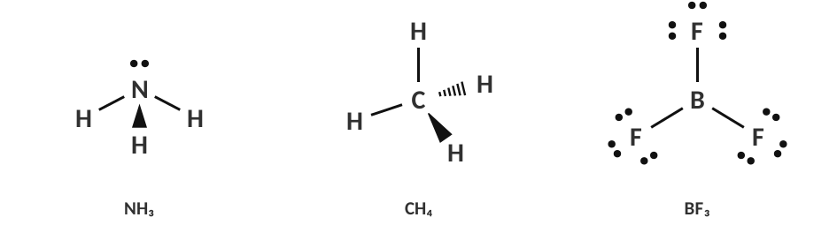
Molecule | Shape | Arrows cancel? | Polar or non-polar?
NH₃ | trigonal pyramidal | no | POLAR
CH₄ | tetrahedral | yes | NON-POLAR
BF₃ | trigonal planar | yes | NON-POLAR

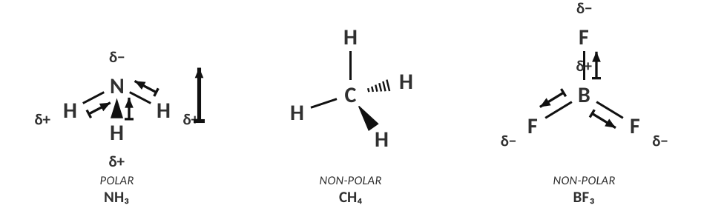
Answers: arrows, partial charges and net dipole.
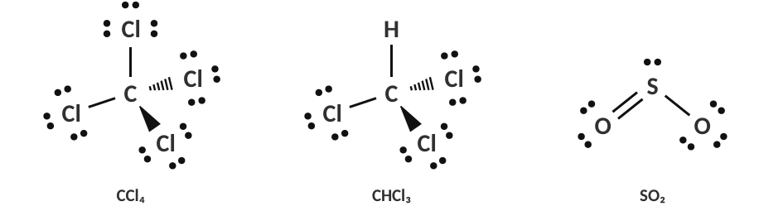
Molecule | Shape | Arrows cancel? | Polar or non-polar?
CCl₄ | tetrahedral | yes | NON-POLAR
CHCl₃ | tetrahedral | no | POLAR
SO₂ | bent | no | POLAR

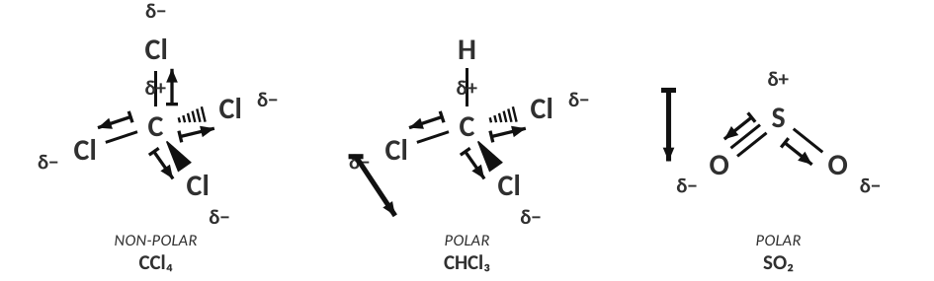
Answers: arrows, partial charges and net dipole.
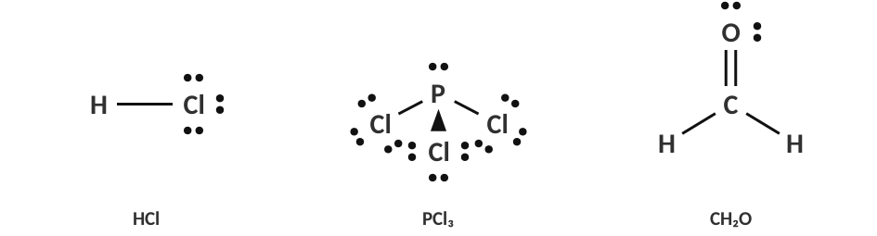
Molecule | Shape | Arrows cancel? | Polar or non-polar?
HCl | linear | no | POLAR
PCl₃ | trigonal pyramidal | no | POLAR
CH₂O | trigonal planar | no | POLAR

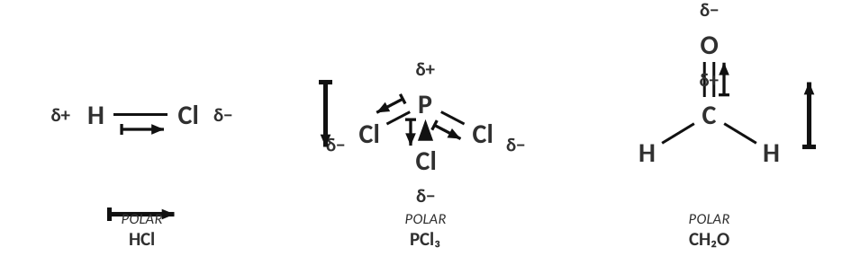
Answers: arrows, partial charges and net dipole.
TEACHER NOTE — POLARITY ANSWERS
CH₂O (formaldehyde) is polar: the C=O dipole is large and the C–H bonds are ignored, so there is a net pull toward oxygen. CHCl₃ is polar because H and Cl pull differently (the three C–Cl dipoles don’t cancel against C–H); CCl₄ is non-polar because the four equal C–Cl dipoles cancel in a tetrahedron. Partial charges: label δ− on the more electronegative atom(s) and δ+ on the less electronegative atom(s).

3. Compare CCl₄ and CHCl₃. Both are tetrahedral with polar C–Cl bonds. Why is only one polar?
In CCl₄ all four bonds are identical and symmetric, so the four dipoles cancel. In CHCl₃ one bond is C–H (essentially non-polar), so the three C–Cl dipoles are not balanced: there is a net dipole.

Rules of thumb for shapes
Shape | Same atoms on every position, no lone pairs on the central atom | Otherwise (lone pairs or different atoms)
Linear | non-polar (CO₂) | polar (HCl, HCN)
Trigonal planar | non-polar (BF₃) | polar (CH₂O)
Tetrahedral | non-polar (CH₄, CCl₄) | polar (CH₃Cl, CHCl₃)
Bent / pyramidal / seesaw / T-shaped | — | always polar (H₂O, NH₃)
Octahedral / trigonal bipyramidal | non-polar (SF₆, PF₅) | polar if different atoms

LAB CORNER • Bending a stream of liquid

A charged plastic rod is held near a thin stream of liquid that is falling from a buret. Water’s stream bends toward the rod; hexane’s stream does not.
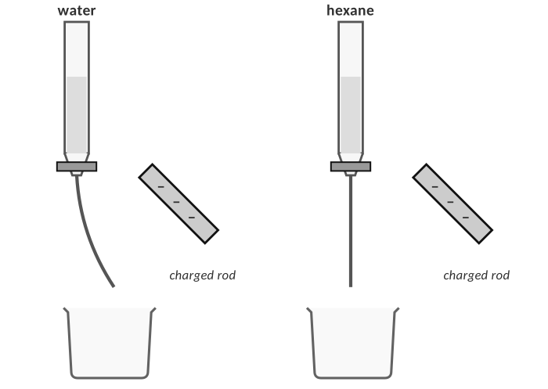
Stream deflection demonstration.
4. Explain the observation for water at the particle level. Draw a quick sketch of how the water molecules line up near the negative rod.
Water molecules are polar: the O end is δ− and the H ends are δ+. A negatively charged rod attracts the H (δ+) ends and repels the O ends, so the molecules rotate and the stream is pulled toward the rod. The molecules orient with their H atoms toward the rod.

5. Hexane (C₆H₁₄) is not deflected. What does that tell you about hexane?
Hexane is a non-polar molecule (C–C and C–H bonds, symmetric), so it has no permanent dipoles to line up with the rod’s charge.

6. If the rod were positively charged instead, would the water stream bend toward it or away from it? Explain.
Still toward it: now the δ− oxygen ends are attracted to the positive rod; the molecules rotate the other way, but the stream is still attracted. A polar liquid is attracted to either sign of charge.

TEACHER NOTE — LAB
Classic demo: rub a balloon/PVC rod on hair or wool, hold near a thin stream of tap water from a buret or faucet. Compare with hexane, cyclohexane or acetone (acetone is polar and also bends; use with a thin stream). Safety: hexane is flammable, no flames; do it in a fume hood or use a small amount in a buret over a beaker.

7. Which bond is the most polar?
A) C–H
B) H–Cl
C) H–O
D) H–F

8. Which molecule is non-polar even though it has polar bonds?
A) H₂O
B) NH₃
C) CO₂
D) HCl

9. Which molecule is polar?
A) BF₃
B) CCl₄
C) PCl₃
D) CH₄

10. What does the arrow in a bond dipole point toward?
A) the less electronegative atom
B) the more electronegative atom
C) the central atom
D) the nucleus

PRACTICE
Extra Practice — Unit 3
Show all work.

A. Ions and compounds
Element | Valence e⁻ | Loses or gains? | Ion symbol and charge
Magnesium | 2 | loses 2 | Mg2+
Chlorine | 7 | gains 1 | Cl−
Oxygen | 6 | gains 2 | O2−
Lithium | 1 | loses 1 | Li+
Phosphorus | 5 | gains 3 | P3−
Calcium | 2 | loses 2 | Ca2+

Metal + non-metal | Ions formed | Formula
potassium + sulfur | K⁺, S²⁻ | K₂S
aluminum + chlorine | Al³⁺, Cl⁻ | AlCl₃
magnesium + nitrogen | Mg²⁺, N³⁻ | Mg₃N₂
calcium + fluorine | Ca²⁺, F⁻ | CaF₂
aluminum + oxygen | Al³⁺, O²⁻ | Al₂O₃
sodium + phosphorus | Na⁺, P³⁻ | Na₃P

B. Classify and predict properties
Compound | Ionic or covalent? | Expected state at 25 °C | Conducts when dissolved?
CaBr₂ | ionic | solid | yes
CH₃OH | covalent | liquid | no
N₂O | covalent | gas | no
Li₂S | ionic | solid | yes
C₁₂H₂₂O₁₁ | covalent | solid | no
SrCl₂ | ionic | solid | yes

A student tests four unknown white solids. Use the data to decide whether each is ionic or covalent.
Solid | Melting point | Conducts as a solid | Conducts when dissolved | Ionic or covalent?
W | 801 °C | no | yes | ionic
X | 186 °C | no | no | covalent
Y | 2072 °C | no | yes | ionic
Z | 54 °C | no | no | covalent

1. Explain how you decided for solid Y, using particles and attractions.
Y has a very high melting point and conducts when dissolved but not as a solid: it is made of ions held in a lattice by strong attractions; they move only when dissolved.

C. Lewis structures, shapes and polarity
Formula | Lewis structure | Shape | Angle | Polar?
H₂S |  | bent | ≈ 92° | polar
CCl₄ |  | tetrahedral | 109.5° | non-polar
BeCl₂ |  | linear | 180° | non-polar
NF₃ |  | trigonal pyramidal | ≈ 102° | polar
CS₂ |  | linear | 180° | non-polar
SF₆ |  | octahedral | 90° | non-polar
CH₂Cl₂ |  | tetrahedral | ≈ 109.5° | polar
SF₄ |  | seesaw | < 90° and < 120° | polar

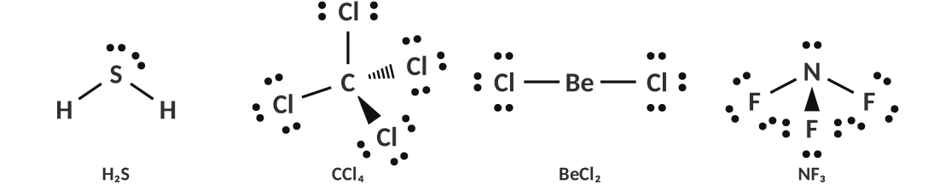
Answers: H₂S, CCl₄, BeCl₂, NF₃
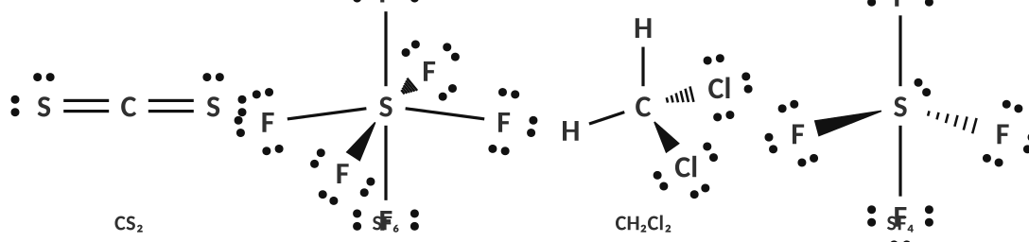
Answers: CS₂, SF₆, CH₂Cl₂, SF₄
TEACHER NOTE
H₂S bond angle is ≈ 92° (the larger central atom has less hybridization); accept “< 109.5°” for Honors. SF₄ is seesaw (polar) because the lone pair sits in an equatorial position.

Bond summary: from formula to polarity
Formula | Bond type (ionic / polar covalent / non-polar) | Shape | Polar molecule?
NaCl | ionic | lattice (no molecule) | n/a
HF | polar covalent | linear | polar
Cl₂ | non-polar covalent | linear | non-polar
PCl₃ | polar covalent | trigonal pyramidal | polar
CO₂ | polar covalent | linear | non-polar
C₂H₆ | non-polar covalent (C–C, C–H) | tetrahedral at each C | non-polar

D. Explain it
2. Explain why solid NaCl does not conduct electricity but molten NaCl does.
In the solid the ions are fixed in the lattice; in the molten state they are free to move and carry the charge.

3. A student claims, “Covalent bonds are weaker than ionic bonds, so covalent compounds melt at low temperatures.” Evaluate the claim.
Not accurate. A covalent bond itself is strong; melting a molecular compound only needs to overcome the weak attractions between separate molecules. Ionic compounds are made of ions bonded together in a lattice, so melting requires overcoming the strong ionic attractions throughout the lattice.

4. Draw the Lewis structures of CO₂ and SO₂. Why does one have a bent shape and the other is linear? Which is polar?
CO₂: no lone pairs on C → linear, non-polar. SO₂: S has one lone pair (3 domains) → bent; the dipoles do not cancel so SO₂ is polar.

5. The bond angle in NH₃ is 107° but in CH₄ it is 109.5°. Explain.
NH₃ has a lone pair on N that repels the three bonding pairs more strongly than the bonding pairs repel each other, pushing the N–H bonds closer together.

6. Use polarity to explain why oil and water do not mix. (Hint: think about the stream demo.)
Water is polar and attracts other polar molecules strongly; oil is made of non-polar molecules that have no strong attraction for water. Water molecules prefer each other, so the oil is pushed out and the liquids form separate layers (“like dissolves like”).

E. Multiple choice
7. Which compound contains BOTH ionic and covalent bonds?
A) NaCl
B) NH₄NO₃
C) CO₂
D) CH₄

8. What is the shape of the sulfate ion, SO₄²⁻?
A) trigonal planar
B) tetrahedral
C) trigonal pyramidal
D) octahedral

9. Which of the following molecules has a triple bond?
A) O₂
B) N₂
C) Cl₂
D) H₂O

10. A molecule with the shape ‘seesaw’ has how many electron domains on the central atom?
A) 3
B) 4
C) 5
D) 6

11. Which pair has the greater ΔEN?
A) C–H
B) N–H
C) O–H
D) Cl–Cl

TOPIC  ★ | Unit 3 Review  Put it in your own words before the test

1. Compare ionic and covalent bonding: which elements, what happens to the electrons, and what the compounds are like.
Ionic: metal + non-metal, electrons transferred, lattice of ions, high melting point, conducts when molten or dissolved. Covalent: non-metal + non-metal, electrons shared, molecules, low melting point, does not conduct.

2. Describe the five steps you follow to go from a formula to a Lewis structure.
Count valence electrons; skeleton with single bonds; octets on outer atoms; remaining electrons on the central atom; make multiple bonds if central atom lacks an octet; check count.

3. What does VSEPR stand for and how do you use it to predict a shape?
Valence Shell Electron Pair Repulsion. Count the electron domains on the central atom; they spread out as far as possible; name the shape from the atoms only (lone pairs are not named).

4. Explain how a molecule can have polar bonds but be non-polar. Give an example.
If the bond dipoles are arranged symmetrically and cancel (CO₂, CCl₄, BF₃).

Concept map
Sample: Formula → metal/non-metal → ionic or covalent → (ionic) lattice, high m.p., conducts molten/dissolved; (covalent) Lewis structure → VSEPR shape → bond dipoles → polar or non-polar → properties.

Sources & further reading
• PhET – Molecule Polarity simulation (University of Colorado Boulder) — https://phet.colorado.edu/en/simulations/molecule-polarity
• PhET – Molecule Shapes simulation — https://phet.colorado.edu/en/simulations/molecule-shapes
• LibreTexts – 5.06 The VSEPR Theory: Molecular Geometry — https://chem.libretexts.org/Courses/can/CHEM₄₁₀:_Chemistry_for_Health_Science/05:_Covalent_Bonding_and_Simple_Covalent_Compounds/5.06:_The_VSEPR_Theory-_Molecular_Geometry
• LibreTexts – 10.02 The VSEPR Model (Lansing CC) — https://chem.libretexts.org/Courses/Lansing_Community_College/LCC%3A_Chem₁₅₁_-_General_Chemistry_I/Text/10%3A_Molecular_Geometry_and_Bonding_Theories/10.02%3A_The_VSEPR_Model
• UCSB MRL – Solution conductivity lesson plan — https://mrlweb.mrl.ucsb.edu/sites/default/files/mrl_docs/ret_attachments/curriculum/solution%20conductivity%20lesson%20plan.pdf
• PASCO – Concentrate on the Conductivity — https://www.pasco.com/resources/blog/12

